Second Sight
https://www.youtube.com/watch?v=Bi_HpbFKnSw
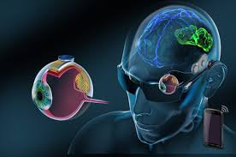 | Fill in the gaps with words related to “vision”. Son las amarillas que he puesto en el parrafo de abajo.

Visual (adjective) prostheses, or "bionic eyes", promise to provide artificial vision (noun) to visual (adverb) impaired people who could previously see. The devices consist of micro-electrodes surgically placed in or near one eye, along the optic nerve (which transmits impulses from the eye to the brain), or in the brain.

Translate the fragments of text into English
In Second Sight Argus II Rhetinal Prosthesis System, a miniature video camera in the eye glasses captures a scene.
The video is processed by a small portable unit and transformed into instructions which son enviadas de vuelta are sent back to the glasses.
These instructions are then transmitted de forma inalámbrica wirelessly to the implant on the eye.
The implant consists of a receiver and una serie an array of electrodes.
Instructions are received and corresponding signals sent to the array, which emits pequeños impulsos small pulses of electricity.
The pulses stimulate the retina's remaining células. cells and are transmitted down the optic nerve llevando conveying visual information to the brain, which perceives patrones de luz patterns of light
Los pacientes patients learn to interpret these visual patterns.

